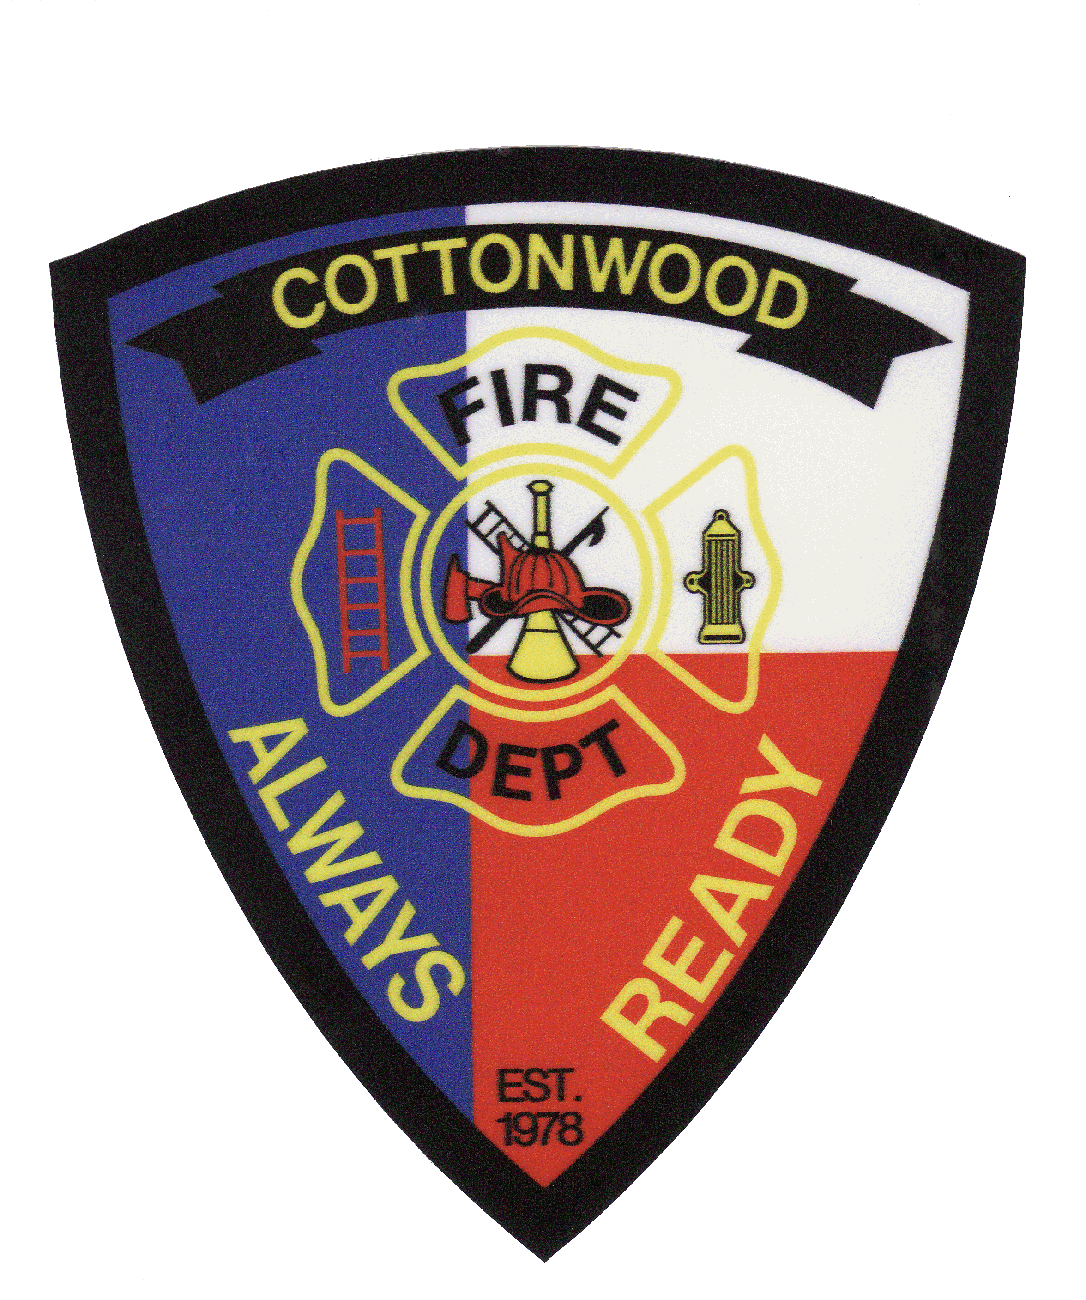
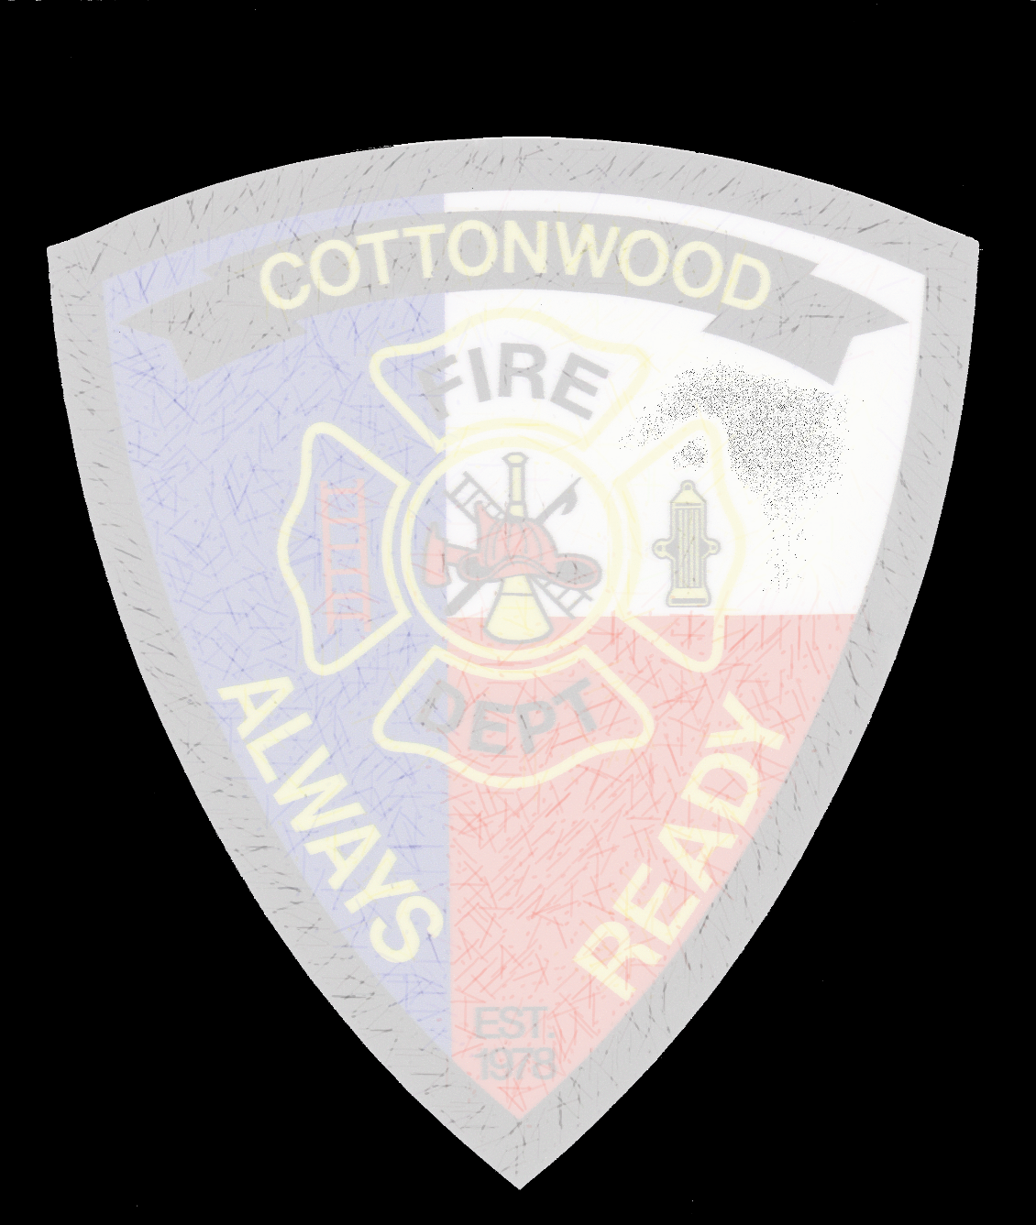
Cottonwood Shores Volunteer Fire Department, INC.
Proudly serving the citizens of Cottonwood Shores and our Neighbors
Office Phone: (830)693-5191 Cell: (830)385-9209 Website: cwsvfd.org Email: Burnpermit@cwsvfd.org
BURN PERMIT

Application Date: ____________________________________________________
Applicant Name: ____________________________________________________
Applicant Address: __________________________________________________
Phone #: ________________________Cell #: ______________________________
Address/Location of Burn: ____________________________________________
Nearest Cross Streets: ________________________________________________
Type of Burn (materials to be burned): __________________________________
Date(s) of Proposed Burn: _____________________________________________
Extinguishment/ Containment Method on Site: ____________________________
Distance to nearest structure: __________________________________________
* Any and all fires and permits are subject to be revoked and/or prohibited due to
unfavorable weather conditions, illegal materials or any other just cause and may be ordered extinguished by Cottonwood Shores Volunteer Fire Department personnel. If a fire should escape the permit holder, all fire department expenses related to extinguishment will be invoiced to the permit holder.
* All fires must be in constant attendance by the permit holder or their designee at all times.
* Please read the City Ordinance 5001 and county ordinance Guidelines before burning.
* Please post this permit somewhere that it can be seen from the road during the prescribed burn.

Approved Permit #: ___________
Denied Reason for Denial: ________________________________________________________
_____________________________________________________________________________________
FD Personnel Inspecting: ____________________________________ Date: _____________________
This Permit is good for 1 week after the date issued.
* The Cottonwood Shores Volunteer Fire Department is charging $20 per permit and payment should be submitted at the time of inspection. You can pay with cash, check, or PayPal.
* For an additional donation we can schedule to have a truck on site during your burn.
Notify BCSO before starting any outdoor burning @ (512)756-8080

